[SATURN 2014 Talk: Understanding Reference Models and Reference Architectures - YouTube](https://www.youtube.com/watch?v=6AIabzrnmqI&t=213s)

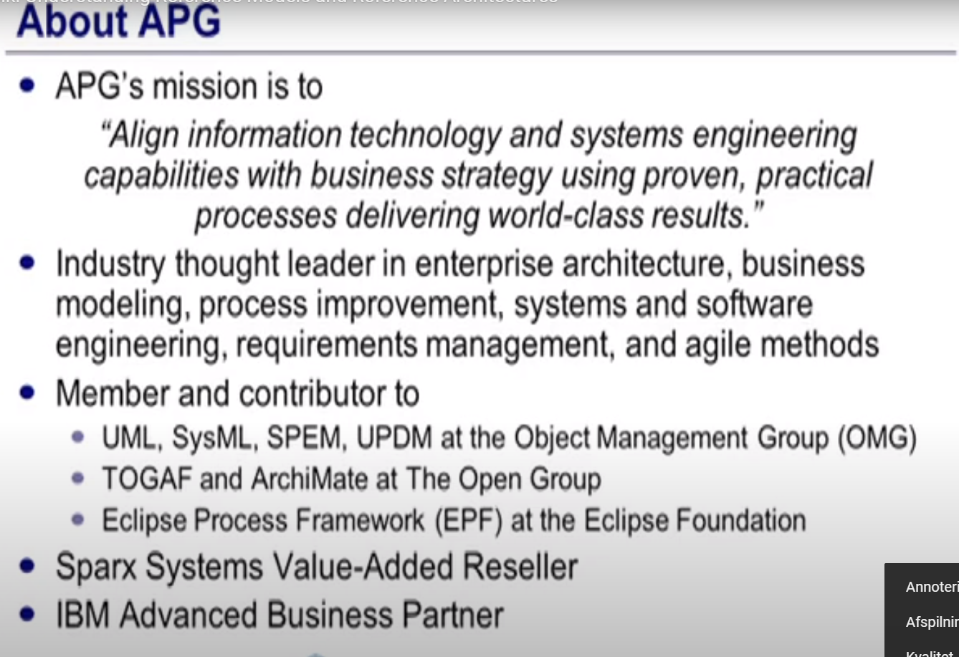

What is a Reference Architecture / Model

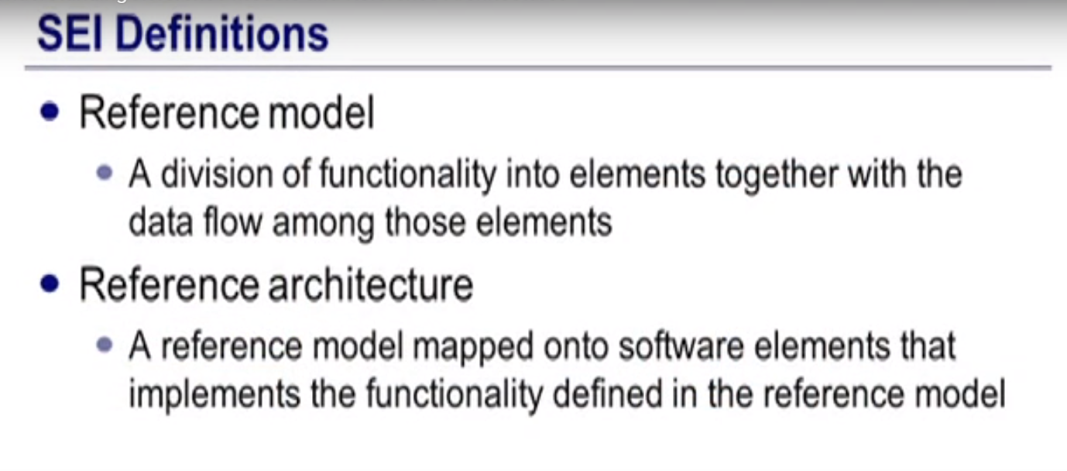

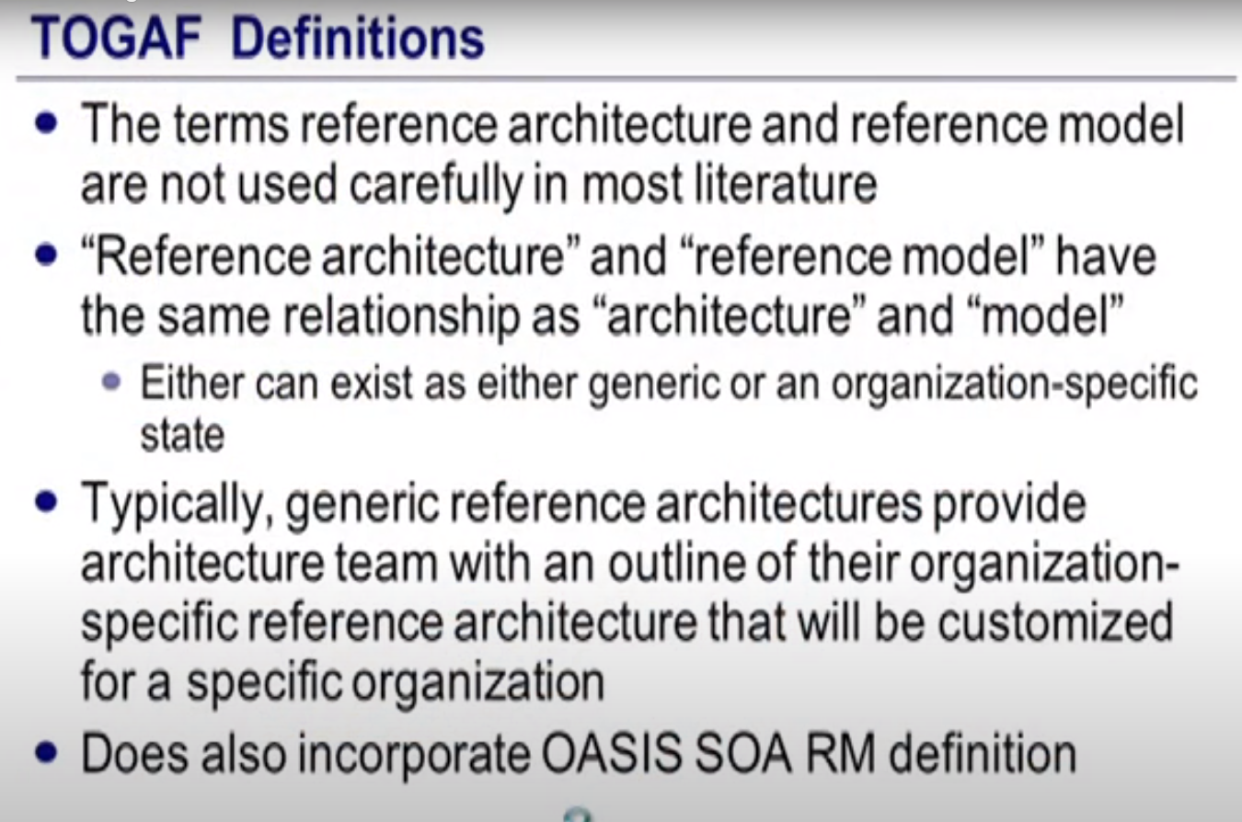

OASIS SOA Reference Model

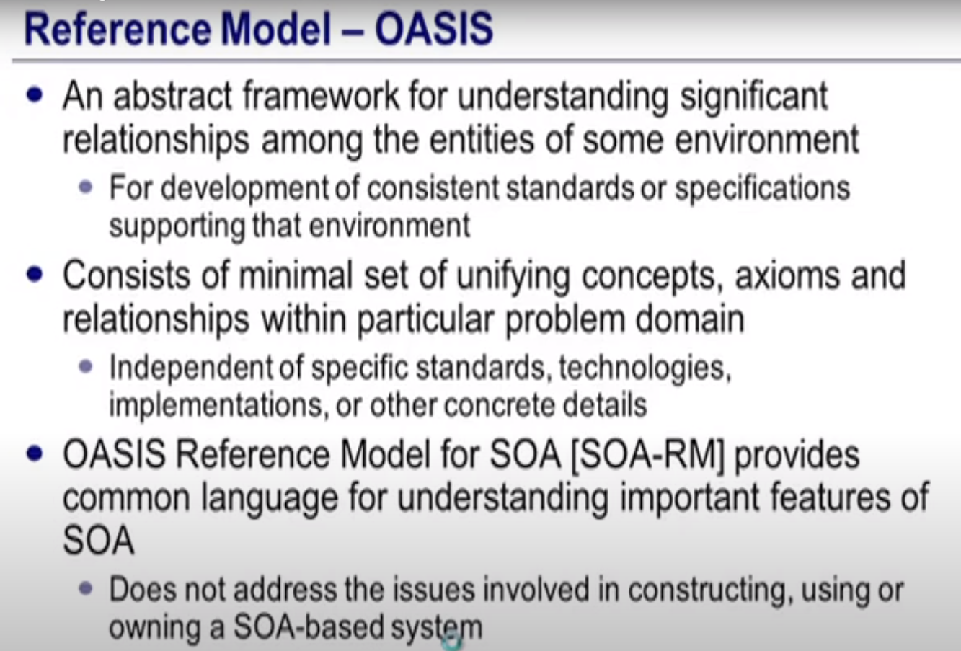

Metamodel – Language – Ontology : same thing…

Industry

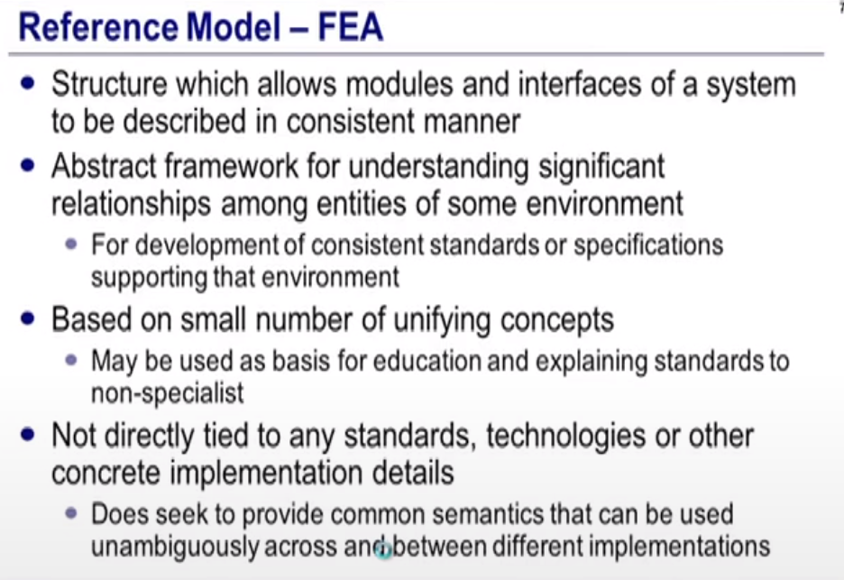

Figure 1 He would call this a domain model...

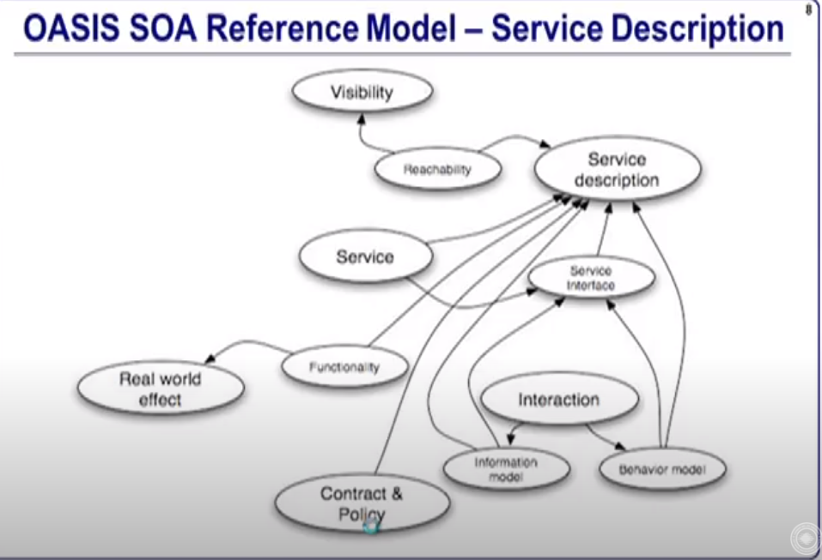

Interaction : brings out information and data model

Technology Reference Model :

Figure 2TRm - Technology Reference Model (Database, Network, Software, Security, ...)

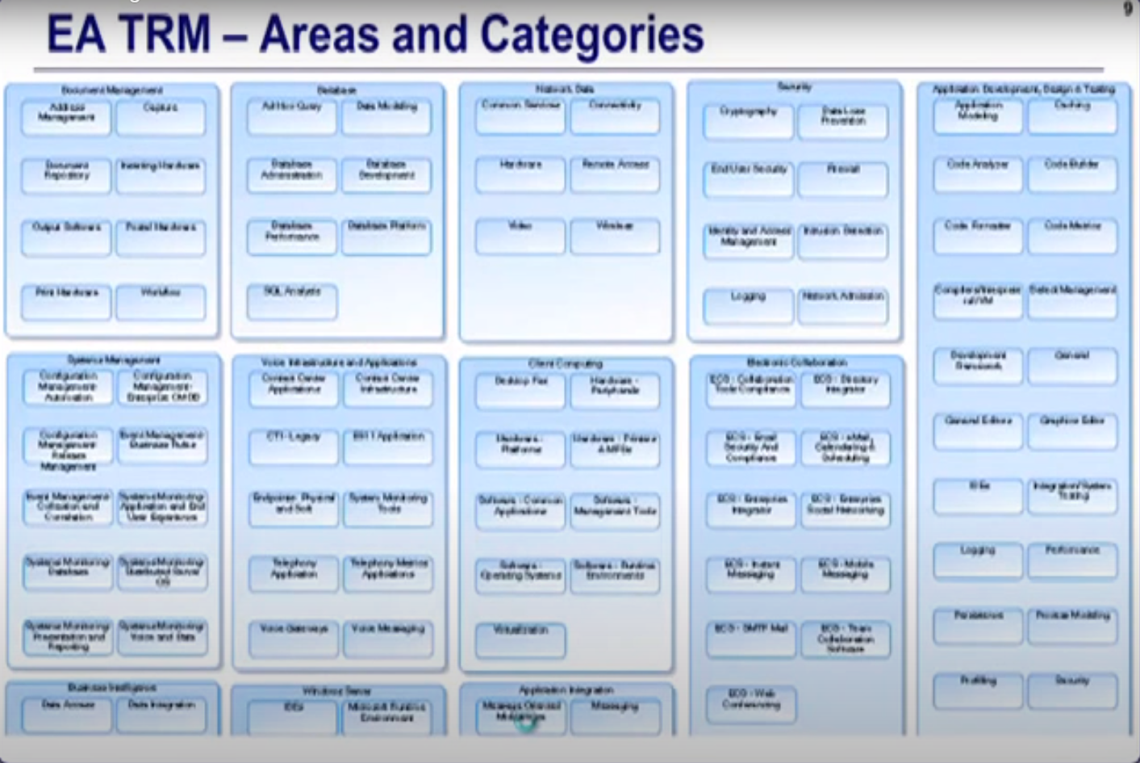

Figure 3Taxonomy Area -> Category -> Component -> Lifecycle (similar to Bricks) Disposition of their Lifecycle.

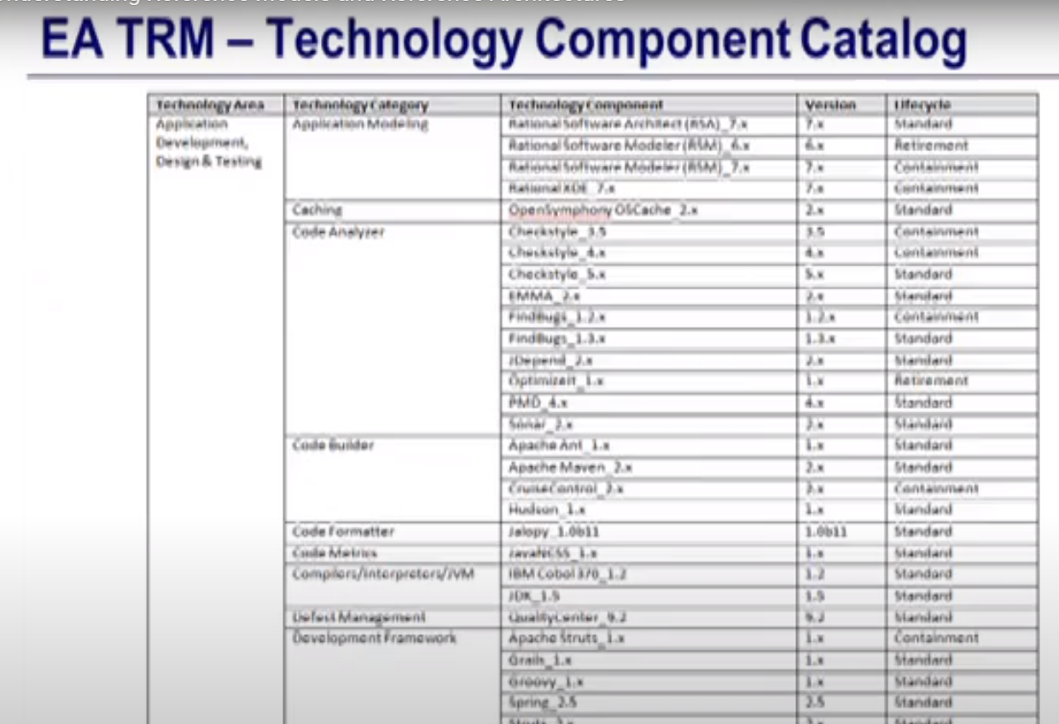

Figure 4 Assets Graphically on Technology Groups

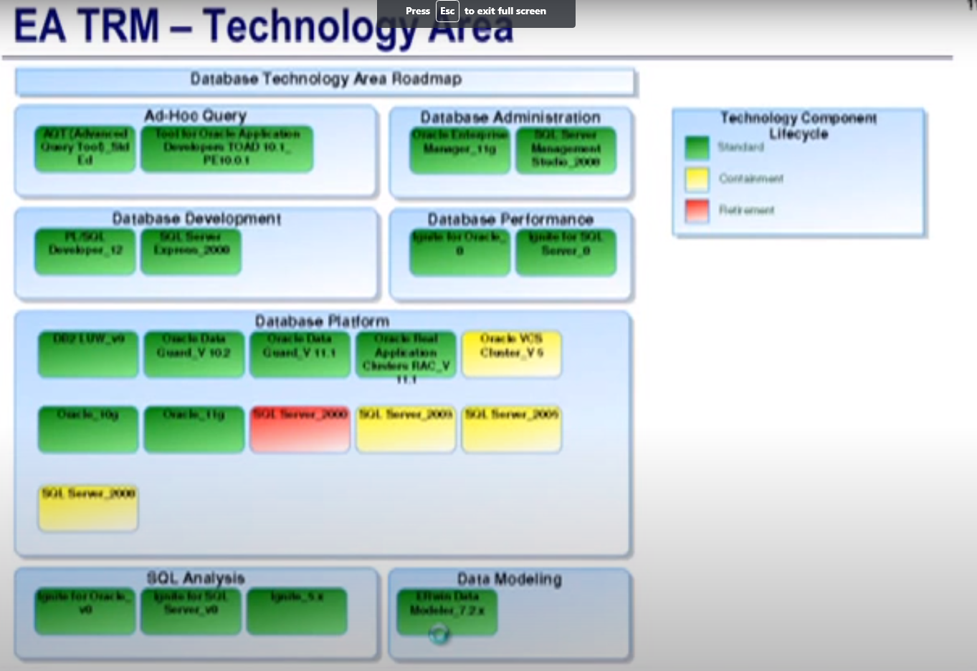

Figure 5Veteran Affairs

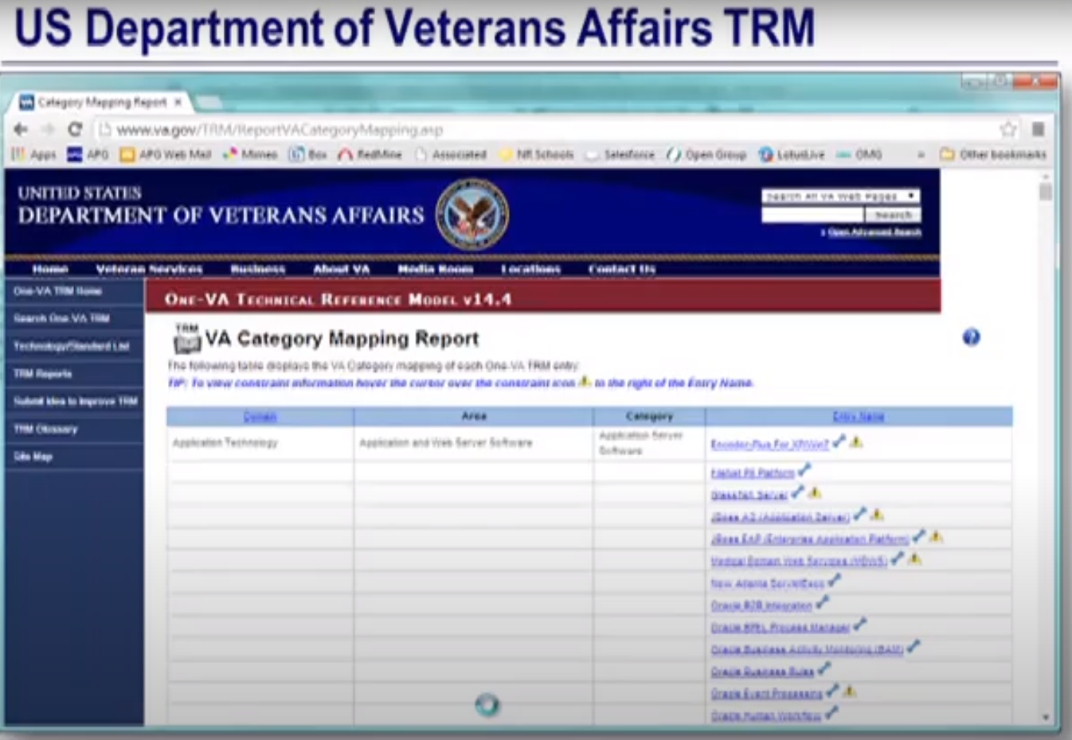

Figure 6VA USA - Architecture Roadmap - Disposition of Assets (JBoss) over time

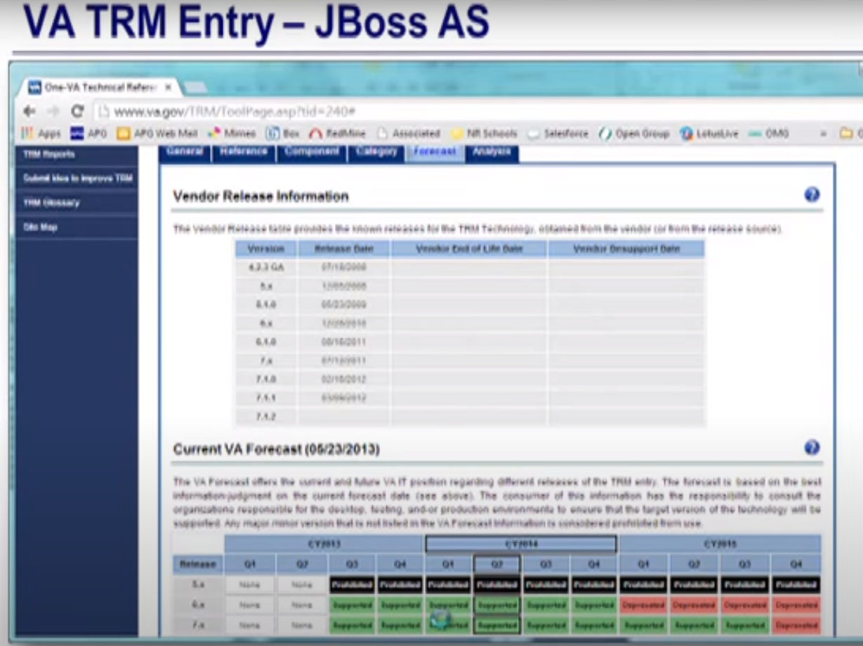

OMB – USA

5 – Performance, Business, Services, Data, Technology,

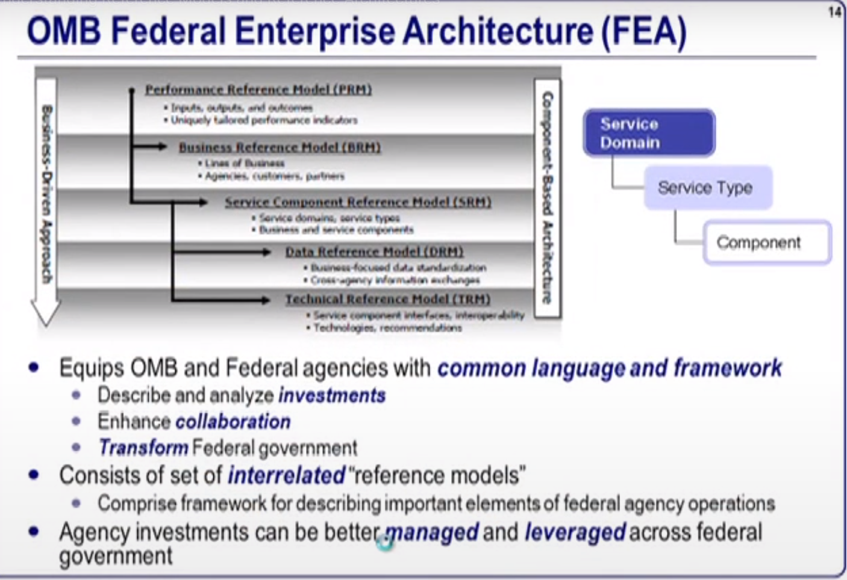

FEA

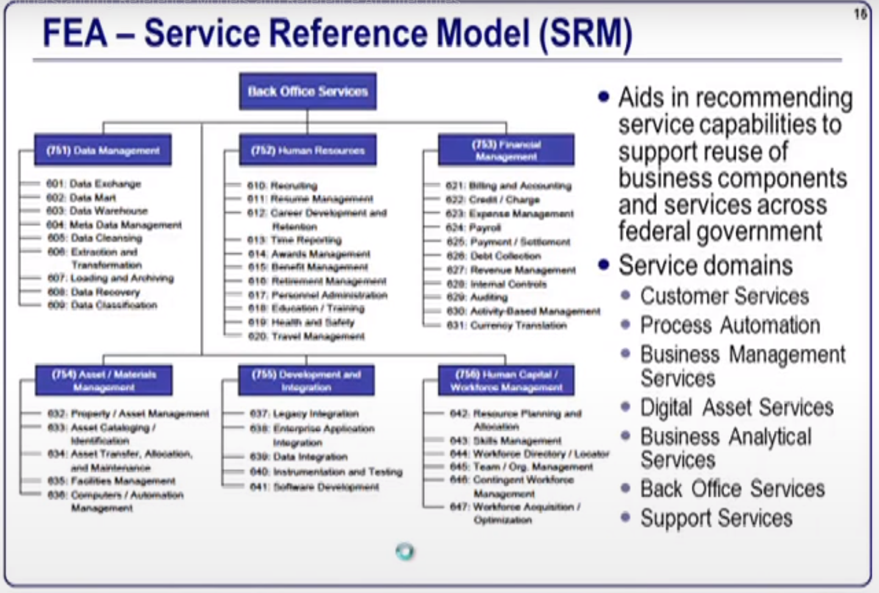

TOGAF

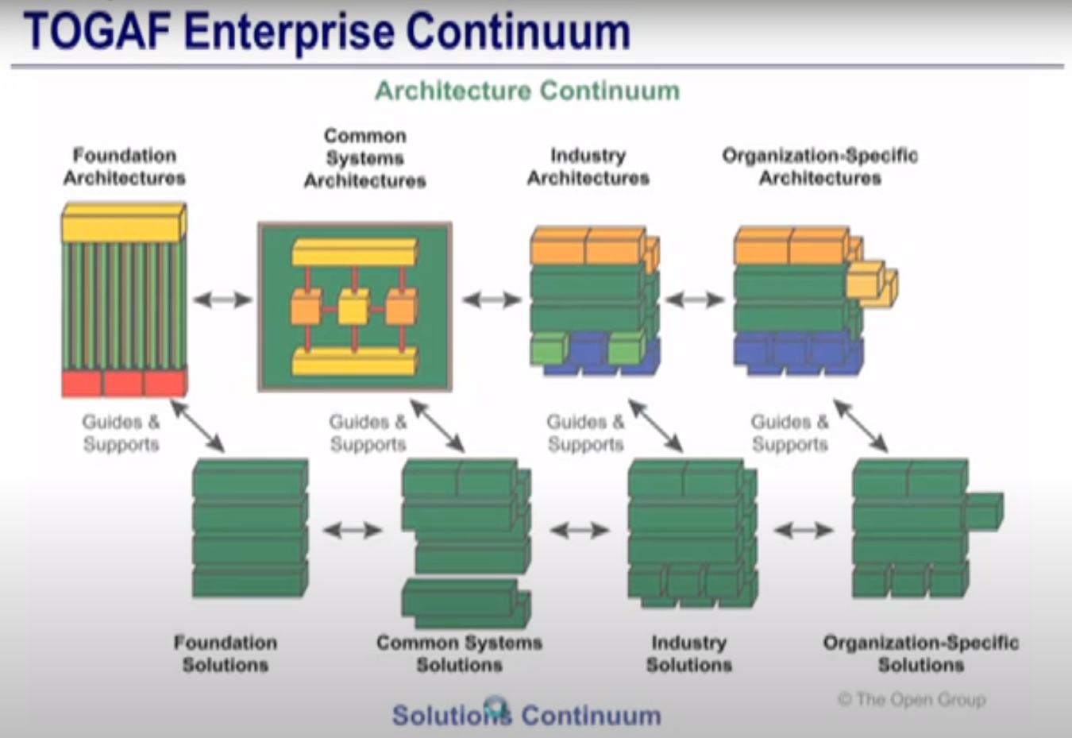

Two Parts to Continuum (diminished importance in TOGAF 9 with introduction of repository)

1. Architecture Continuum (spectrum of reusable to fit-for-purpose – customized, but easier to re-use in the context of which they were designed) – requirements, and properties (the solution building blocks are the implementers of the behaviour and requirements.

2. Solution Continuum (describes standard or specification,

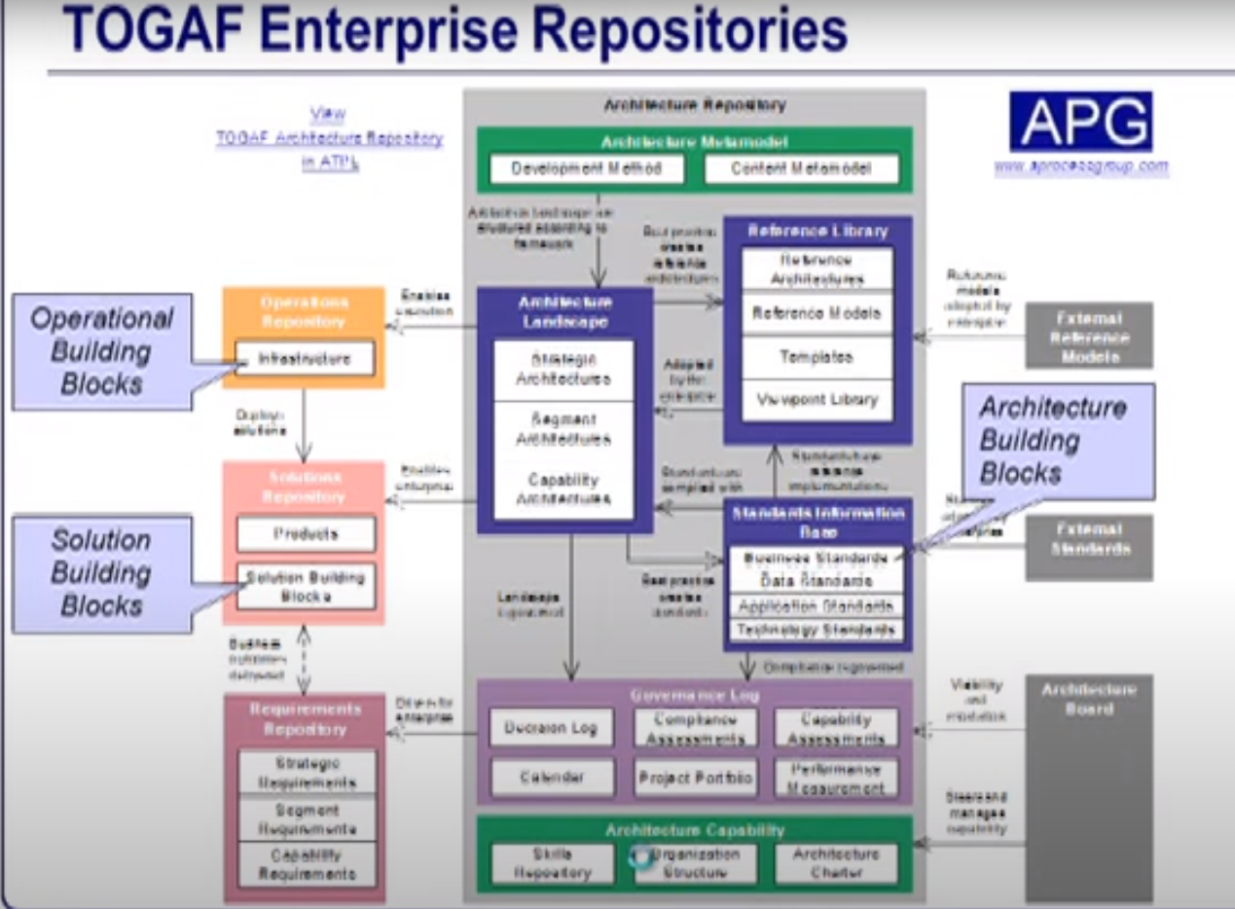

Figure 7 With Quality Attributes

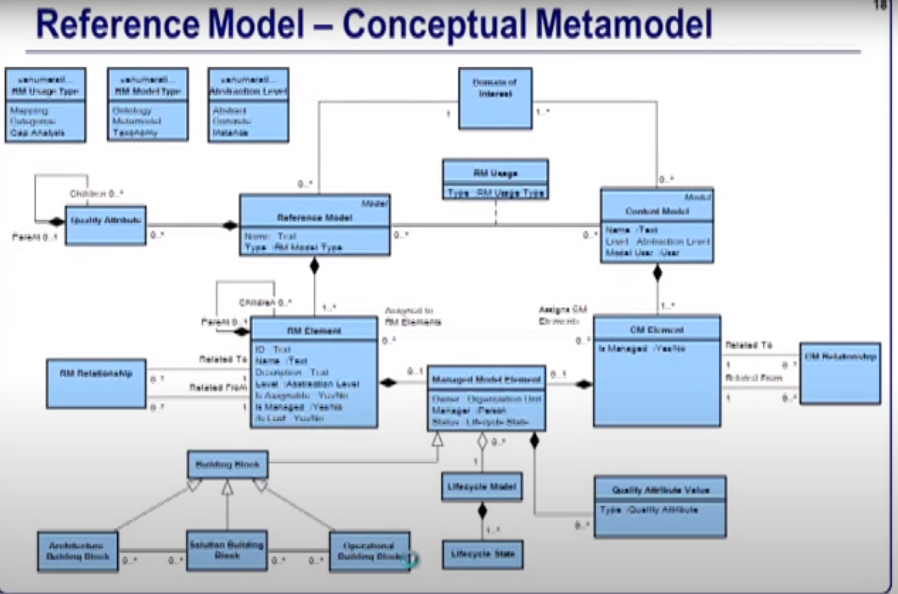

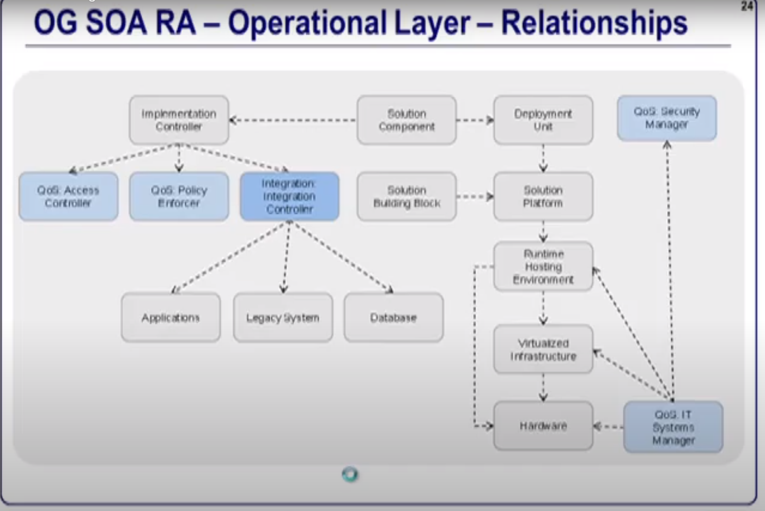

Figure 8Ref Model is a model, Ref Arch is an Arch Description (multi levels of abstraction)

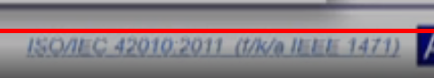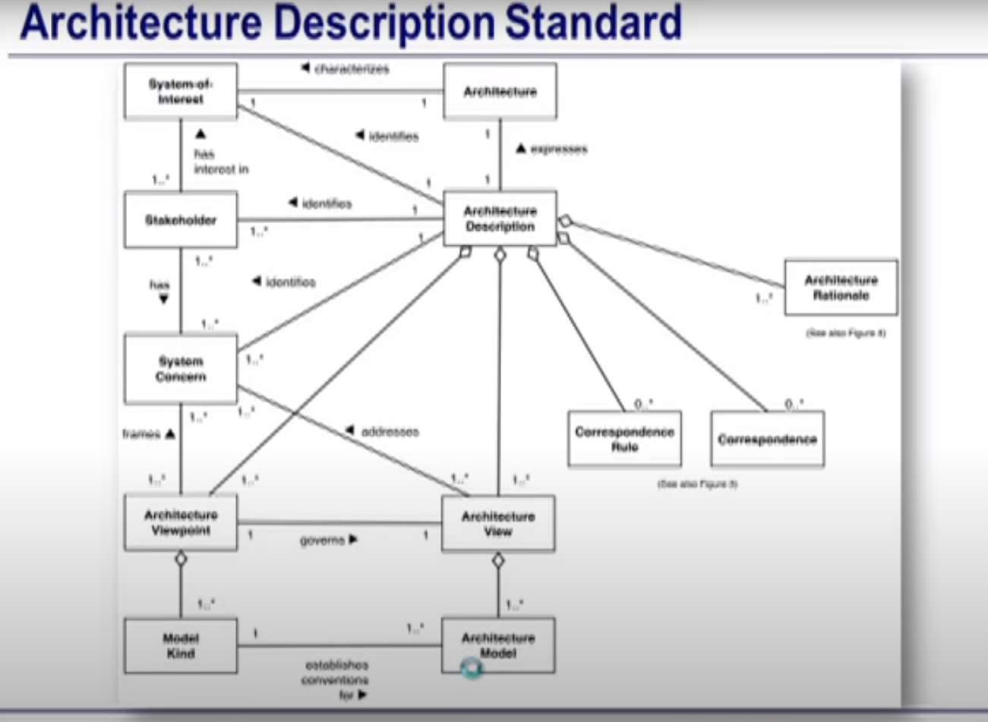

Different Levels:

1. Architecture
2. Design
3. Implementation

